Description of the Downloadable Tools

The following documents and tools may be downloaded by readers:
- Project Workflow Process Hierarchy
- Project Risk Assessment Tool
- Earned Value Analysis Tool
- Client Satisfaction Survey Tool

All tools are developed on MS Excel platform. They are intended to save project managers’ time calculating project risk scores, doing the Earned Value Analysis and quantify the level of your clients’ satisfaction based on their answers to several questions. The tools have never been intended as fully fledged applications. One of the book’s authors developed it for his own use and they served well since 1998, updating them from time to time until 2010.

All tools are templates, meaning that a new copy of the tool will be created every time you open the template, leaving the template intact. You may save results as a project document under a meaningful name and access later when needed. If some of you are curious enough to know how it is all done and damage the tool in the process, just discard the damaged copy and open the tool template again.

All tools are in .xltm format, which is the macro enabled template. In order to run tools you must allow Excel running macros. Neither of tools contains any macros, but they use some VB controls and run code, which will not work if macros are disabled. When saving results, the tool will automatically propose to save it as .xlsx regular spreadsheet, rather than the macro enabled .xlsm spreadsheet. Excel will issue warning, that you may lose some functionality if you do that. If the saved work will be used only as a document, rather than a tool, then go ahead and save it. Just remember that the saved copy may have limited functionality if used as a tool. In order to run a fresh copy of the tool, run a corresponding template.

Because of the imbedded code and VB controls, none of the known today Excel compatible applications will work on Android or Apple tablets.

Risk Assessment Tool

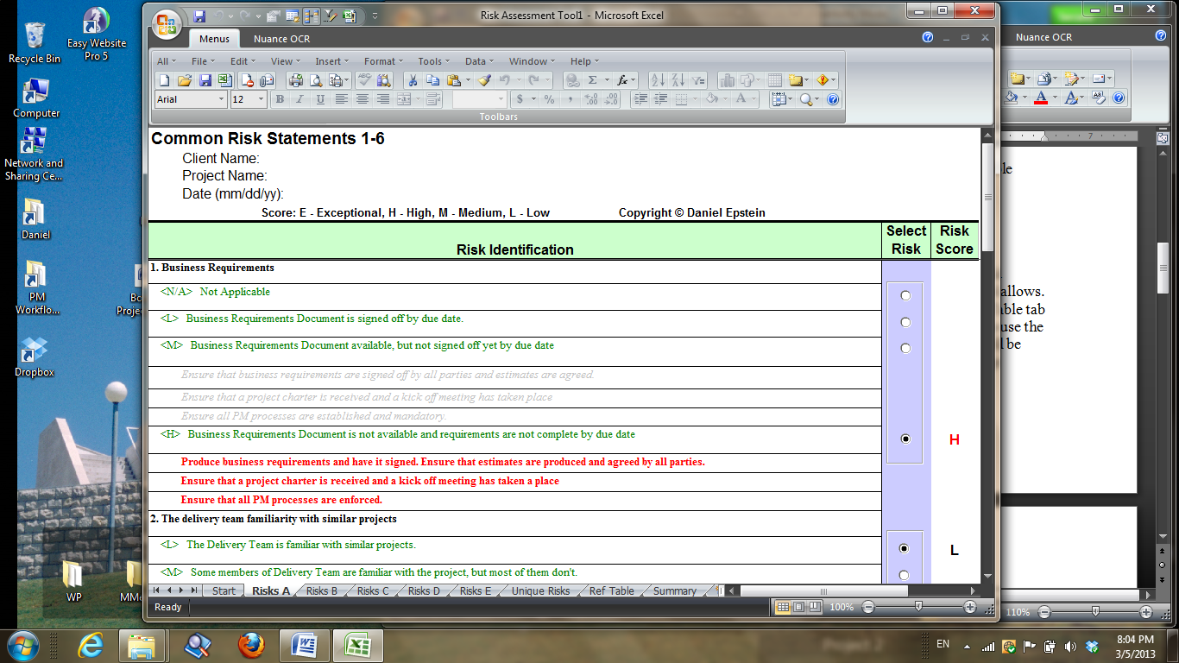

The tool may be used for small to medium size projects up to $1M. Bigger projects would require more standard risk statements and much more space for unique risks then the tool allows. Having larger projects in mind, the reference table for risk scores is provided in the Ref Table tab and calculation of the normalized risk score is shown in Summary tab. You don’t need to use the table and calculate normalized risk score for small to medium size projects, because it will be done by the tool. However, you may use them as a reference when assessing risks of large projects over $1M.

This spreadsheet is set up with multiple tabs to assess standard risks and to add risks which are unique to your project. The risk assessment process begins with Start page, where you enter Client Name, Project Name and Date. This information will propagate through all sheets of the spreadsheet. Then go through all tabs from left to right, labeled Risks A through Risks E, reading all risk statements sequentially and selecting the most applicable to your project risk definitions. Each risk definition is preceded with letters <L>, <M>, <H> or <E>, indicating which risk score will be assigned to the risk if selected. The tool will rate the risk of each selected risk definition as Low, Medium, High or Exceptional and display each rating in the Risk Score column. For every High, Exceptional and some Medium risks the tool will display the suggested risk response to your selected risk definition, which may be entered into your Risk Response Plan document.

When this part is complete, proceed to the Unique Risks tab and add description of risks, which are unique to your project. Then select Risk Severity and the Probability of each risk occurrence. The resulting risk score will be displayed on the right. The Ref Table tab shows how the resulting risk score is figured out from a combination of risk impact and probability of the risk occurrence. The Reference Table is provided for your information only. The Summary tab displays a composite view of your project’s Risk Score and the method of the normalized risk score calculation for your reference.

As described in the book, you must not start project if the project normalized risk score for the project is other than Low, which corresponds to score under 41. Regardless of the total project score, you still must eliminate or convert at least High and Exceptional risks to Low by using one of the methods described in the book. If, in the course of the project you discover a new risk, it too, must be eliminated or converted to Low risk before proceeding.

Use the tool on your own risk, since the tool is nothing but a calculator. It is a good idea to estimate the Expected Monetary Value (EMV) of all risks as described in the book, even if the total risk score is Low. If the total EMV comes to more than 15% of the project budget, review your plans and environment again to see what can be done to reduce it to the level below 10%.

Earned Value Analysis Tool

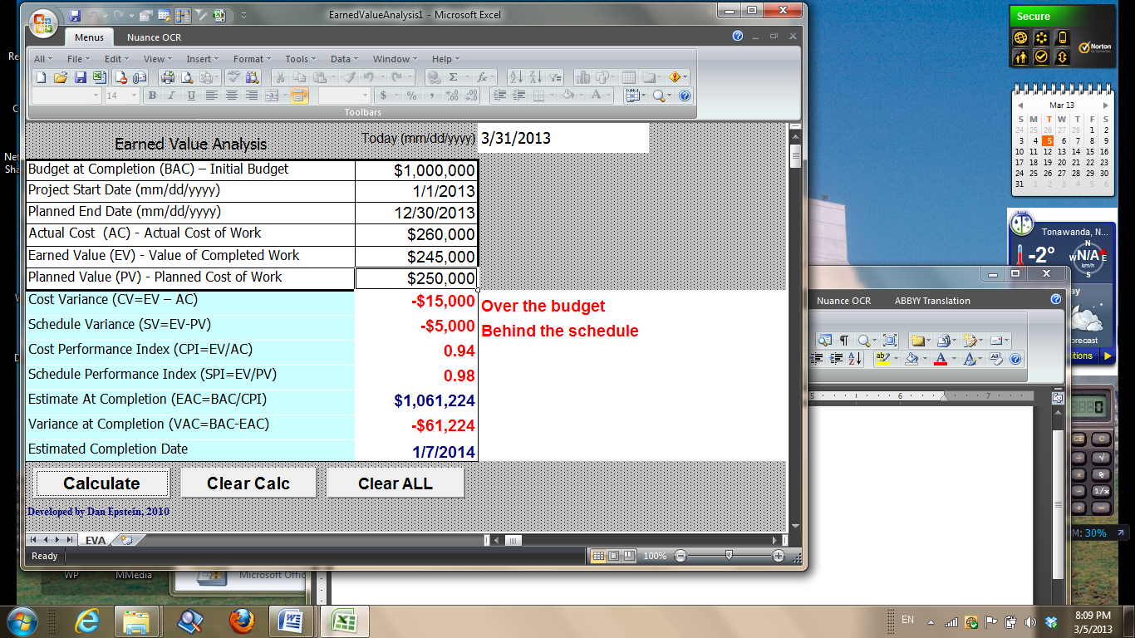

The tool will automate your Earned Value Analysis.

In order to calculate EVA, you must enter the following:

- Initial project budget (BAC)
- Project start date and the planned end date
- Actual cost of the accomplished work (AC)
- The planned cost of the finished work (PV)
- The value of the completed work (EV)

You should be able to get this information from your scheduling tool. Most tools, including MS Project, Clarity, Primavera and others, have this information available, provided that hourly rates of all resources was entered into the scheduling tool and the project was baselined before the work started. If your scheduling tool does not provide you with the above data, then, for sure, your boss does not know what EVA is or does not care about that.

Entering date is optional, but it is a good habit to enter date on all documents you create.

Click on Calculate button and the results of EVA calculation will be displayed:

- Cost Variance (CV)
- Schedule Variance (SV)
- Cost Performance Index (CPI)
- Schedule Performance Index (SPI)
- Estimated cost of the project by the time it is completed (EAC)
- Variance at Completion (VAC)
- Estimated project completion date

CV and SV values will be positive or zero for a project in good health. CPI and SPI will be 1.0 or above if the project is healthy. Other values are self explanatory.
Not relying on your judgment, the tool will indicate “Behind the schedule” and/or “Over the budget”, when the project performance is below expectation. Besides, all values indicating poor project performance will be highlighted in red.

If mistake is made during data entry or you would like to exercise entering different values and see new EVA results, click on Clear Calc button, then modify your entries and click on Calculate button again.

If you want to start EVA calculation from scratch, click on Clear ALL button and start all over again.

Client Satisfaction Survey Tool

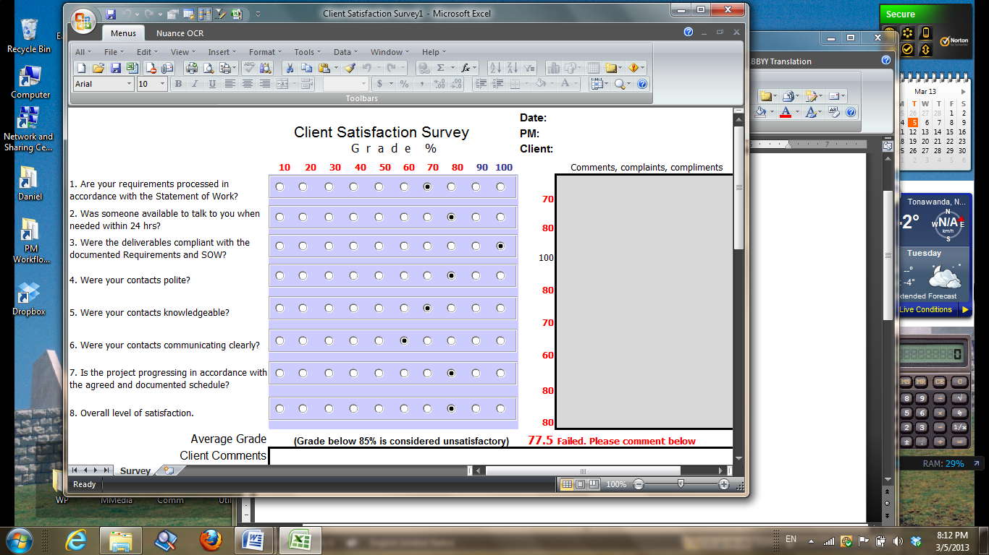

The tool will quantify your client’s feeling about you, as a project manager, and your project team, based on client’s satisfaction grades of seven project areas and one grade for overall satisfaction.

Each grade assigned corresponds to the level of client satisfaction between 10% and 100%.
The overall grade will be displayed by the tool. If the overall grade is less than 85%, it is considered unsatisfactory and must prompt investigation by management. The client must explain his/her reasons of dissatisfaction in the Client Comments area at the bottom of the screen.

Those organizations that feel the cut off level of 85% is too high and should be lowered don’t need this tool. Probably, they don’t need the other tools either.

